Reflex Angle
# Source: AI Source: Provided by: [Data Path: Persons Table -> ID Column: 1, Name_En Column: Motasem Essam] -> From: [ChatGPT] on [7/25/2026]
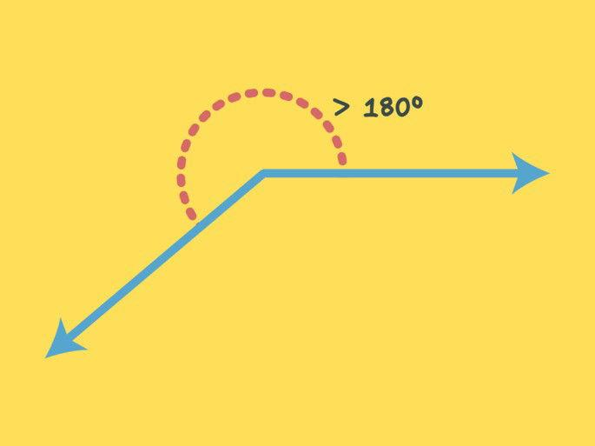
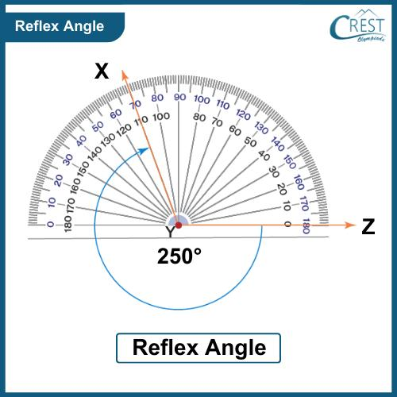
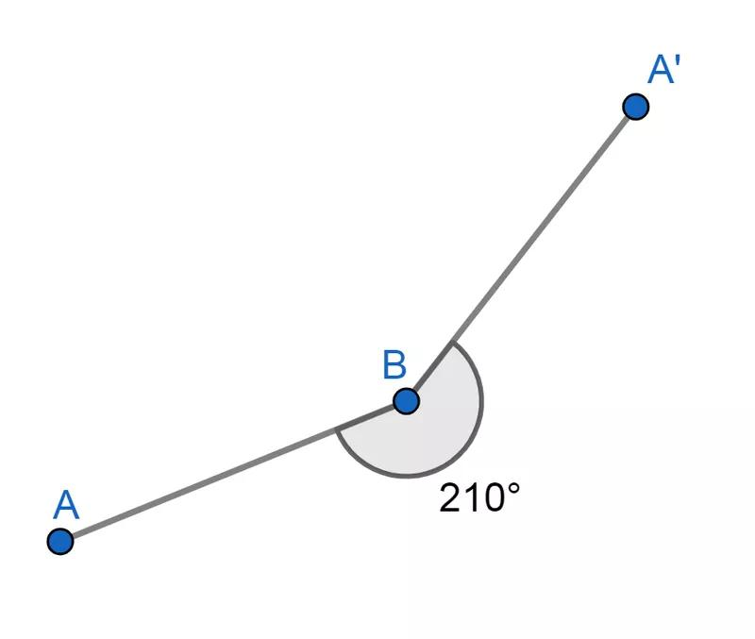
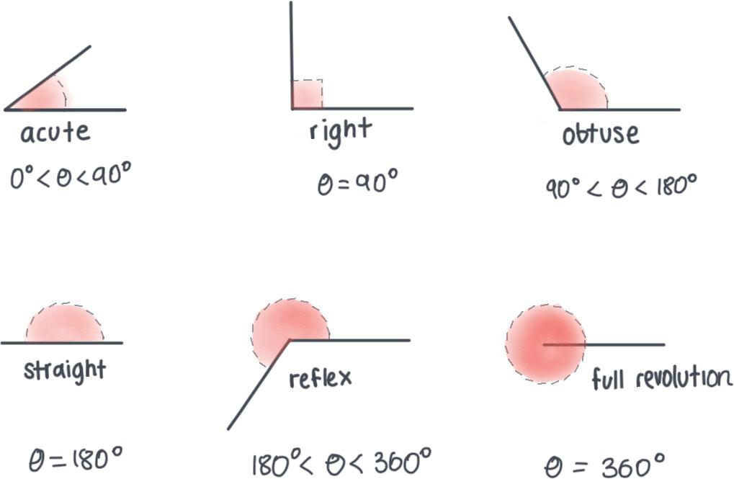
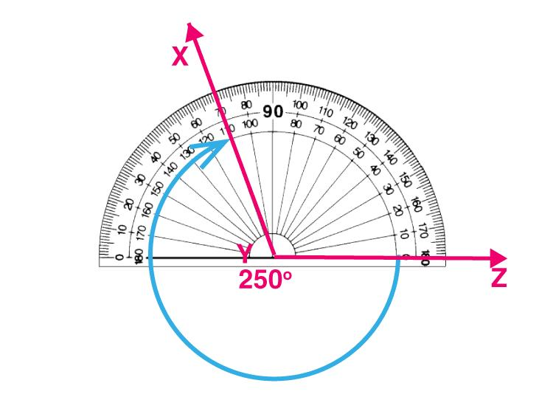

Definition
# Source: AI Source: Provided by: [Data Path: Persons Table -> ID Column: 1, Name_En Column: Motasem Essam] -> From: [ChatGPT] on [7/25/2026]
A Reflex Angle is an angle whose measure is greater than ${180}^{∘}$ but less than ${360}^{∘}$. It is larger than a straight angle but smaller than a complete angle.
A reflex angle represents the larger rotation between two rays around their common vertex.

Characteristics
# Source: AI Source: Provided by: [Data Path: Persons Table -> ID Column: 1, Name_En Column: Motasem Essam] -> From: [ChatGPT] on [7/25/2026]
A reflex angle:
- Measures more than ${180}^{∘}$.
- Measures less than ${360}^{∘}$.
- Is larger than a straight angle.
- Is smaller than a complete angle.
- Is formed by two rays sharing a common vertex.
- Represents more than half of a full rotation.

Illustration
# Source: AI Source: Provided by: [Data Path: Persons Table -> ID Column: 1, Name_En Column: Motasem Essam] -> From: [ChatGPT] on [7/25/2026]
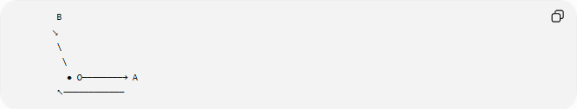
B
↘
\
\
● O────────→ A
↖────────────
The larger outside opening between the rays represents the reflex angle.

Mathematical Representation
# Source: AI Source: Provided by: [Data Path: Persons Table -> ID Column: 1, Name_En Column: Motasem Essam] -> From: [ChatGPT] on [7/25/2026]
A reflex angle satisfies:
$${180}^{∘}<θ<{360}^{∘}$$
or in radians:
$$π<θ<2π$$

Examples
# Source: AI Source: Provided by: [Data Path: Persons Table -> ID Column: 1, Name_En Column: Motasem Essam] -> From: [ChatGPT] on [7/25/2026]
Common examples include:
$${200}^{∘} \\ {225}^{∘} \\ {270}^{∘} \\ {300}^{∘} \\ {350}^{∘}$$

Coordinate Geometry
# Source: AI Source: Provided by: [Data Path: Persons Table -> ID Column: 1, Name_En Column: Motasem Essam] -> From: [ChatGPT] on [7/25/2026]
Suppose two rays originate from:
$$O\left(0,0\right)$$
Ray 1 points along:
$$A\left(5,0\right)$$
Ray 2 points along:
$$B\left(0,5\right)$$
The smaller angle between them is:
$${90}^{∘}$$
The reflex angle is the remaining rotation:
$${360}^{∘}-{90}^{∘}={270}^{∘}$$
Therefore:
$$θ={270}^{∘}$$

Reflex Angle and Rotation
# Source: AI Source: Provided by: [Data Path: Persons Table -> ID Column: 1, Name_En Column: Motasem Essam] -> From: [ChatGPT] on [7/25/2026]
A reflex angle represents more than half of a complete turn:
$${180}^{∘}<θ<{360}^{∘}$$
A complete rotation is:
$${360}^{∘}$$

Real-World Examples
# Source: AI Source: Provided by: [Data Path: Persons Table -> ID Column: 1, Name_En Column: Motasem Essam] -> From: [ChatGPT] on [7/25/2026]
Reflex angles appear in:
- Clock hands showing large rotations.
- A door opened beyond a straight position.
- Circular motion paths.
- Rotating mechanical parts.
- Radar and scanning systems.

Properties
# Source: AI Source: Provided by: [Data Path: Persons Table -> ID Column: 1, Name_En Column: Motasem Essam] -> From: [ChatGPT] on [7/25/2026]
A reflex angle:
- Has one vertex.
- Has two rays forming the angle.
- Measures between ${180}^{∘}$ and ${360}^{∘}$.
- Uses the larger angular region.
- Can be measured using a protractor (often by measuring the smaller angle and subtracting from ${360}^{∘}$).

Measuring a Reflex Angle
# Source: AI Source: Provided by: [Data Path: Persons Table -> ID Column: 1, Name_En Column: Motasem Essam] -> From: [ChatGPT] on [7/25/2026]
To measure a reflex angle:
- Measure the smaller angle:
$$θ_{s}$$
- Subtract from a complete angle:
$$θ_{r}={360}^{∘}-θ_{s}$$
Example
If the smaller angle is:
$${80}^{∘}$$
then the reflex angle is:
$${360}^{∘}-{80}^{∘}={280}^{∘}$$

Applications
# Source: AI Source: Provided by: [Data Path: Persons Table -> ID Column: 1, Name_En Column: Motasem Essam] -> From: [ChatGPT] on [7/25/2026]
Reflex angles are used in:
- Plane Geometry
- Coordinate Geometry
- Trigonometry
- Engineering
- Mechanical Design
- Robotics
- Computer Graphics
- Animation
- CAD (Computer-Aided Design)

Advantages
# Source: AI Source: Provided by: [Data Path: Persons Table -> ID Column: 1, Name_En Column: Motasem Essam] -> From: [ChatGPT] on [7/25/2026]
Studying reflex angles helps to:
- Understand large rotations.
- Analyze circular motion.
- Describe complex angular positions.
- Design rotating mechanisms.
- Work with polar coordinates.

Limitations
# Source: AI Source: Provided by: [Data Path: Persons Table -> ID Column: 1, Name_En Column: Motasem Essam] -> From: [ChatGPT] on [7/25/2026]
A reflex angle:
- Cannot equal:
$${180}^{∘}$$
- Cannot equal:
$${360}^{∘}$$
- Requires identifying the larger angle region.

Comparison with Other Types of Angles
# Source: AI Source: Provided by: [Data Path: Persons Table -> ID Column: 1, Name_En Column: Motasem Essam] -> From: [ChatGPT] on [7/25/2026]
Angle Type | Measure
Zero Angle | $$0^{∘}$$
Acute Angle | $$0^{∘}<θ<{90}^{∘}$$
Right Angle | $${90}^{∘}$$
Obtuse Angle | $${90}^{∘}<θ<{180}^{∘}$$
Straight Angle | $${180}^{∘}$$
Reflex Angle | $${180}^{∘}<θ<{360}^{∘}$$
Complete Angle | $${360}^{∘}$$

Key Points
# Source: AI Source: Provided by: [Data Path: Persons Table -> ID Column: 1, Name_En Column: Motasem Essam] -> From: [ChatGPT] on [7/25/2026]
- A Reflex Angle measures:
$${180}^{∘}<θ<{360}^{∘}$$
- In radians:
$$π<θ<2π$$
- It is the larger angle between two rays.
- It represents more than half of a full rotation.
- A reflex angle can be calculated using:
$${360}^{∘}-\text{smaller angle}$$

Conclusion
# Source: AI Source: Provided by: [Data Path: Persons Table -> ID Column: 1, Name_En Column: Motasem Essam] -> From: [ChatGPT] on [7/25/2026]
A Reflex Angle is an angle greater than ${180}^{∘}$ and less than ${360}^{∘}$. It represents the larger rotation between two rays sharing the same vertex. Reflex angles are important for understanding circular movement, rotations, and complex geometric relationships. They are widely used in plane geometry, coordinate geometry, trigonometry, engineering, mechanical design, robotics, CAD, animation, and computer graphics, where large rotations and angular positions must be accurately represented.

